If ... Else in One Line
There is also a shorthand syntax for the if-else statement that can be used when the condition being tested is simple and the code blocks to be executed are short. Here's an example:
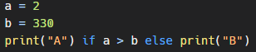
You can also have multiple else statements on the same line:

Example
One line if else statement, with 3 conditions:
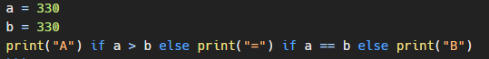
Another Example
This syntax is equivalent to the following if-else statement:
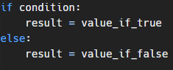
Conclusion
The shorthand syntax can be a convenient way to write simple if-else statements, especially when you want to assign a value to a variable based on a condition. \
However, it's not suitable for more complex situations where you need to execute multiple statements or perform more complex logic. In those cases, it's best to use the full if-else syntax.

